

 Know Your TX – Dissecting a Transaction  
  
**Objective/Aim:**  
  
 To study and understand about TX and how to dissect a transaction.

**Apparatus/Software Used:**

* Laptop/PC
* Remix IDE
* Sepolia tesnet
* Internet for research

**Theory/Concept:**

* 1. A transaction (TX) in the context of cryptocurrency refers to the movement of assets or data between entities on a blockchain network. It represents the transfer of cryptocurrency from a sender to a receiver, and this exchange is recorded on the blockchain, ensuring transparency and security
  2. To dissect a transaction, one can **use a block explorer, which allows users to look up the transaction details and confirmations using the transaction ID (TXID) or transaction hash (Tx Hash)**. The transaction hash is a unique identifier that contains information such as the sender's address, the receiver's address, the amount transferred, the time, and other relevant details.

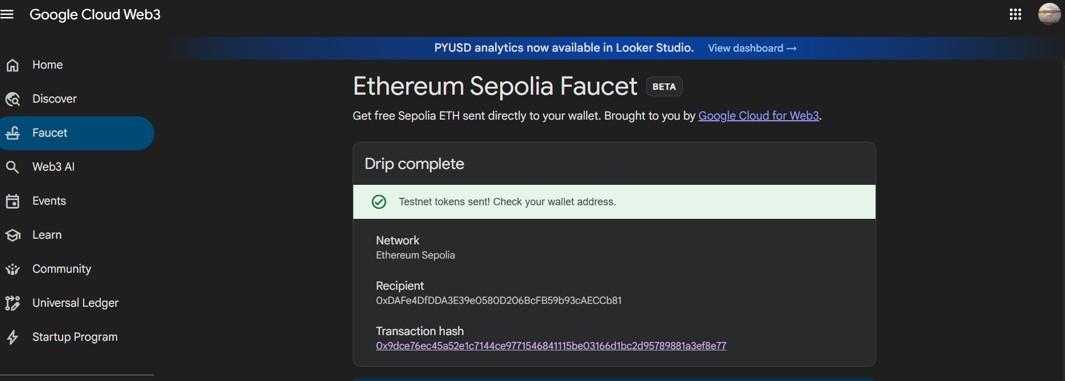

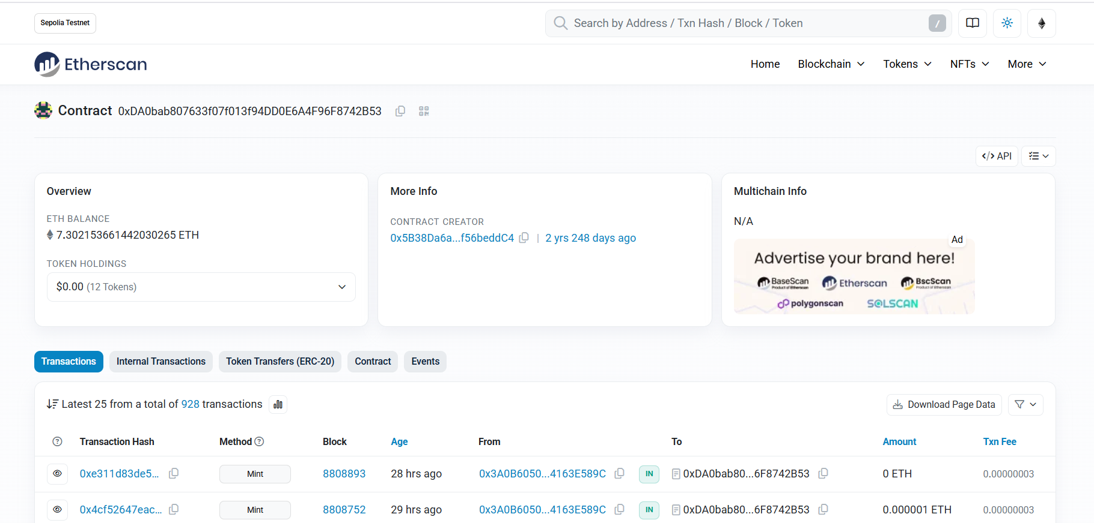

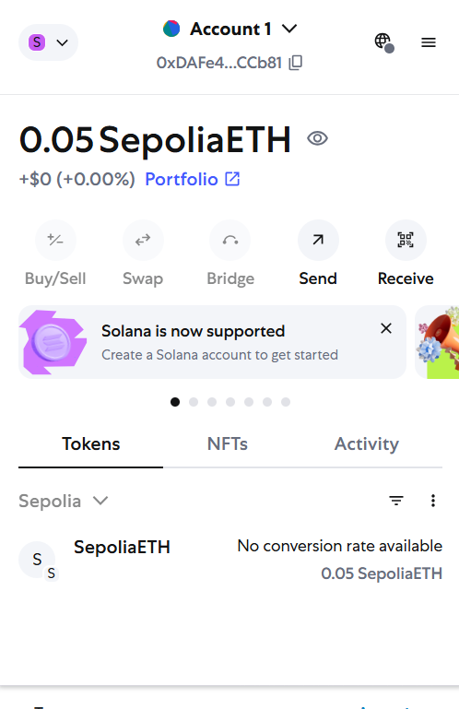

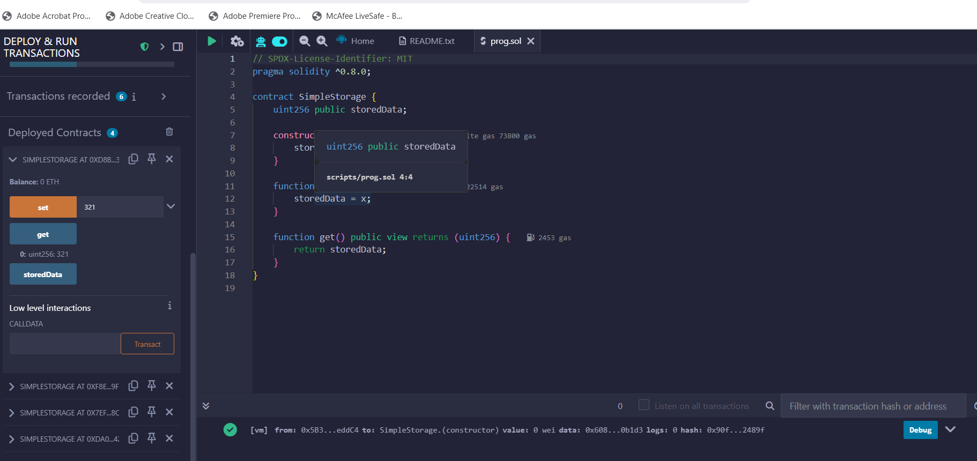



**Procedure:**

|  |  |  |  |
| --- | --- | --- | --- |
|  |  |  |  |
|  |  |  |  |
|  |  |  |  |
|  |  |  |  |
|  |  |  |  |
|  |  |  |  |
|  |  |  |  |

1. **Start the transaction**: Initiate the transaction to group multiple database operations into a single unit of work.
2. **Disable auto-commit**: Turn off the auto-commit mode to prevent each SQL statement from being automatically committed.
3. **Execute SQL statements**: Perform the necessary database operations such as updates, inserts, or deletes within the transaction.
4. **Commit the transaction**: If all operations are successful, commit the transaction to make the changes permanent in the database.
5. **Rollback the transaction**: If any operation fails, rollback the transaction to undo all changes and restore the database to its previous consistent state.
6. **Handle exceptions**: Implement error handling to catch any exceptions that occur during the transaction and decide whether to commit or rollback based on the error.
7. **Close the connection**: Ensure that the database connection is properly closed after the transaction is completed.

**Observation Table:**

1. Identify transactions and source documents: Transactions must be first identified and corroborated with source documents like receipts, invoices, or bank statements.
2. Analyse transactions using the accounting equation: Each transaction is examined to see how it affects the accounting equation: Assets = Liabilities + Owner’s Equity.
3. Record journal entry: After the analysis, the transaction is recorded in the journal as a journal entry, capturing the debit and credit aspects as per double-entry bookkeeping.

**:**







|  |  |  |
| --- | --- | --- |
|  |  |  |
|  |  |  |
|  |  |  |
|  |  |  |
|  |  |  |
|  |  |  |
|  |  |  |
|  |  |  |
|  |  |  |
|  |  |  |
|  |  |  |
|  |  |  |